**Personal Portfolio Template**

(Group 96)

(Hugh Duong-Tran-Tien n9747362)

(Github - https://github.com/hughdtt/IFB299-Team96/)

**Artefact 1** – (Code for Reservation)

This includes the code currently stored in reservation; the bulk of if it being forms.py, views.py and all the template htmls.

The code allows for users (who are logged in) to reserve an order for any searched car. The information (if valid) is stored into the database. The user is then redirected to a success page and then home page.

For form CSS, third party “Crispy Forms” were used for easier integration with Bootstrap.

I wrote most of the structure for the code and the logic used was important when creating other areas of the webapp – ie. Account Creation forms using ModelForms

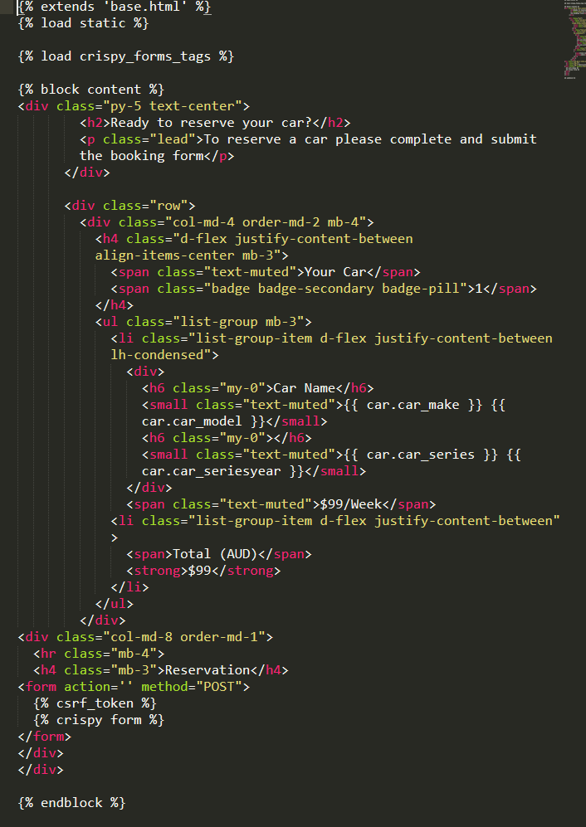

‘**Reservation Form Html’** – IFB299-Team96/Project/Reservation/Templates

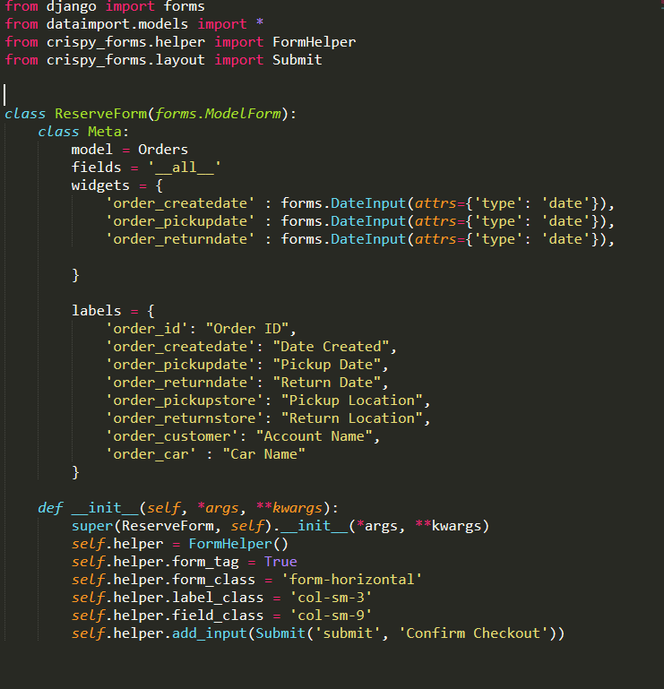

**‘Reservation Form.py’** - IFB299-Team96/Project/Reservation/

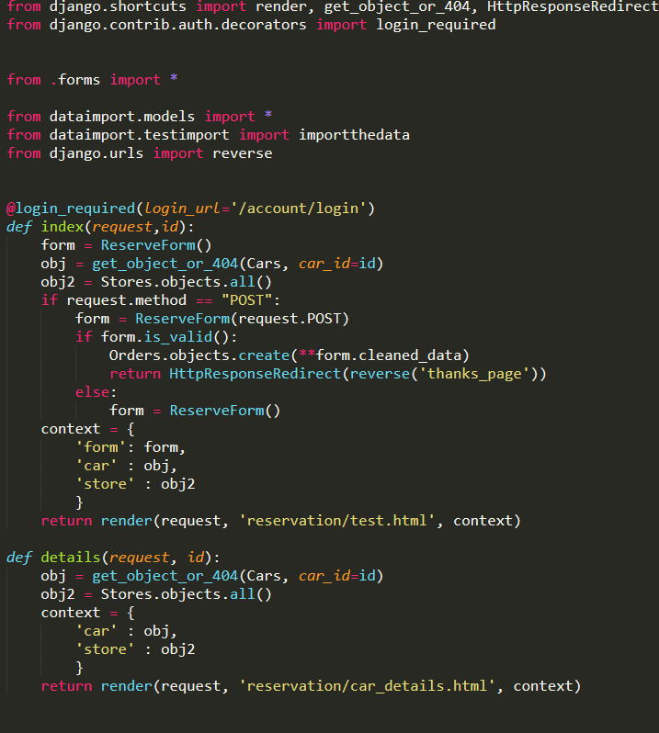'

**‘Reservation Views.py’** - IFB299-Team96/Project/Reservation/

**Artefact 2** – (Code for Car Details)  
This currently mainly consists of the code found in reservation/car_detail.html. Also implemented dynamic urls for reservation so details page retrieves the right car.

This was important as it improved cohesion of the site – allowed for reservation process to flow like: search car 🡪 car details 🡪 reserve

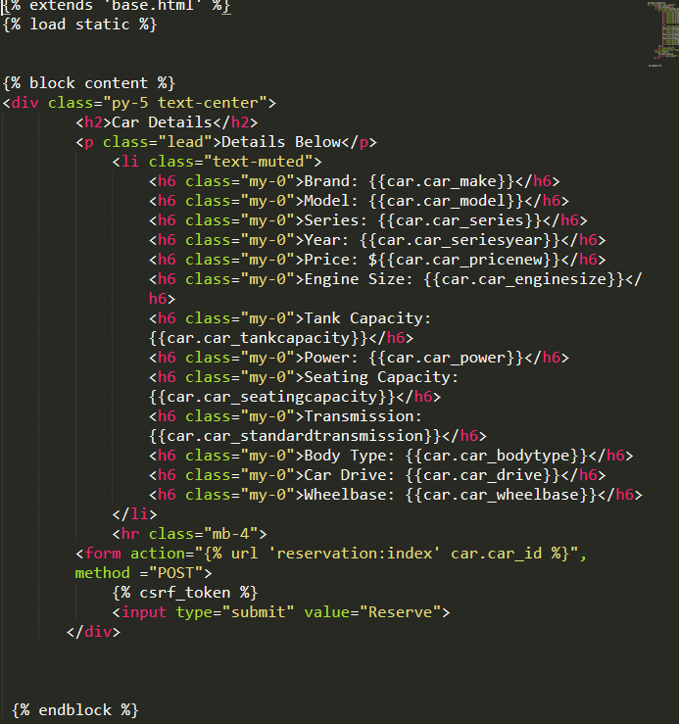

‘**Car Details Html’** - IFB299-Team96/Project/Reservation/Templates

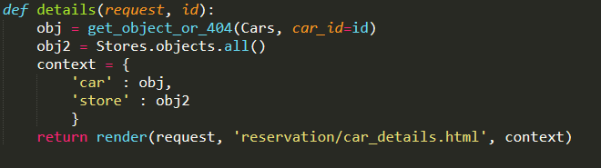

‘**Details Snippet from Reservation Views.py’** - IFB299-Team96/Project/Reservation/

**Artefact 3** – (Code for Account Registration shared w/ Michael)

Code found in account; views.py, forms.py – htmls done by Michael.

Uses Django built in UserCreationForm to create users directly into database. There’s validation for the forms – ie. only secure passwords will work.

Customer details to add to database will be implemented next sprint; however, the code is partially developed in the forms.py

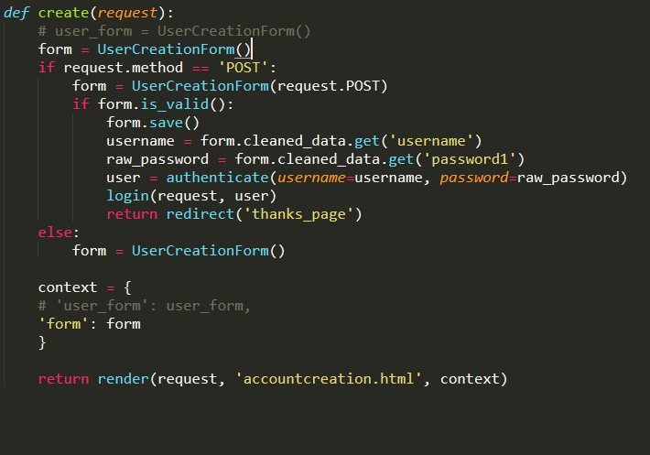

‘**Create User in Account Views.py’** - IFB299-Team96/Project/Account/

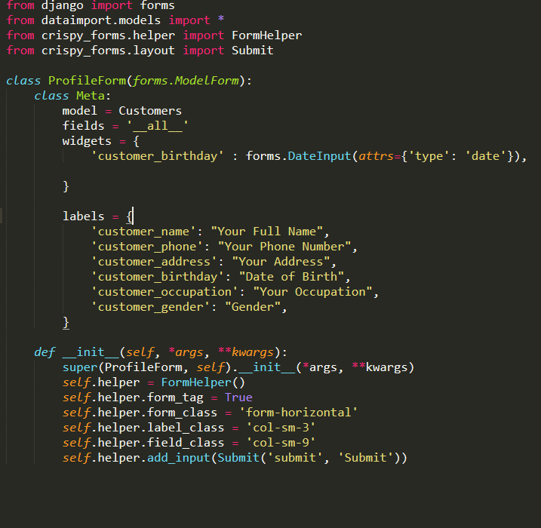

‘**ModelForm in Account Forms.py’** - IFB299-Team96/Project/Account/

**Artefact 4** – (Edited/Finalised Acceptance Criteria w/ Zac )

Gives developers criteria for completion of user story. They were individually edited for flow in logic and specificity.

These were important as it gave developers a real understanding on how the end product should work and be tested.

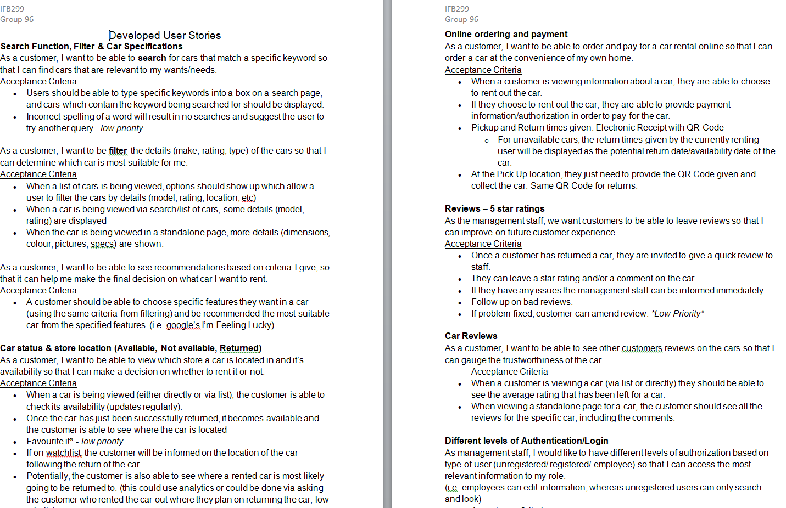

**‘Developed Acceptance Criteria -** IFB299-Team96/Formal Documentation/Developed User Stories.docx

**Artefact 5** – (Car Details Page Mockup)

A Mockup made using the Online Moqups App.

This mockup features a fairly standard layout for the Cars detail page. It highlights the Car image, import Car details as well as a review/ comment section.

It’s important to have mockups to give developers a better understanding of the end product and how it should look. This is because the layout may impact how the developer designs the code.

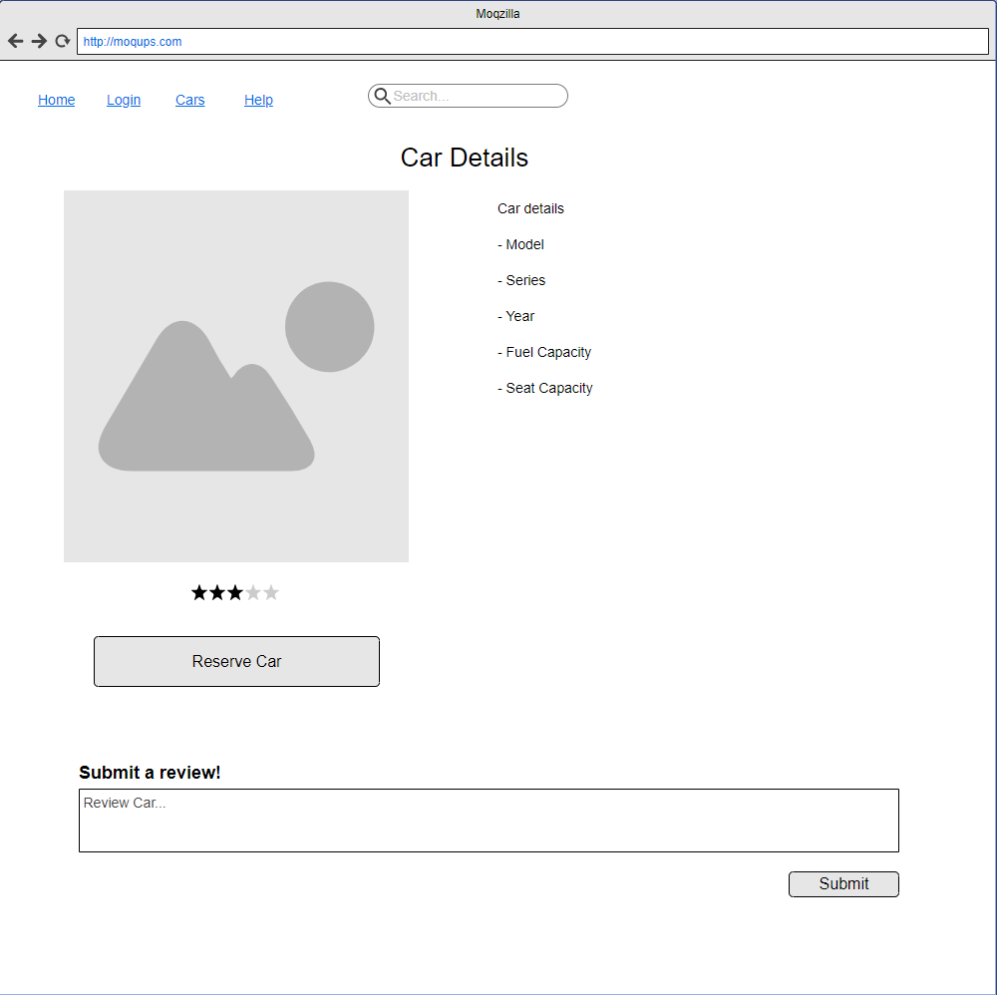

**‘Details Mockup’** – IFB299-Team96/Formal Documentation/Car Details Page.PNG